SchoolMessenger Opt-In Directions

- Text any of the following words (Subscribe, Optin, Opt in, Yes or Y) to the number 67587. Press Enter.

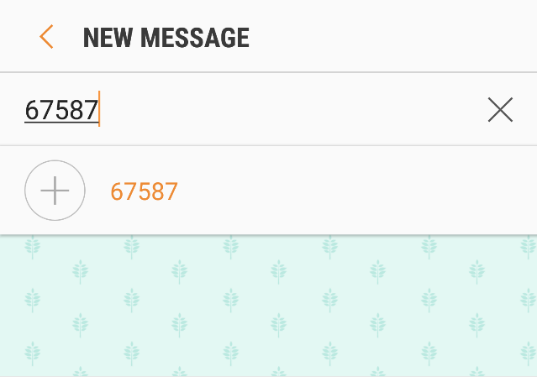

- Click Y when the following message displays.

- The following message will display when completed.

